Name: kulsoom Alias Koonj

CMS ID: 023-20-0104

Lab 8

**ACTIVITIES SECTION**

# ACTIVITY 1: STEPS

⇨ Create windows forms application named dsApp.

⇨ Create a form in it.

⇨ Place DataGridView on form.

On Form_Load event write following code in the form.

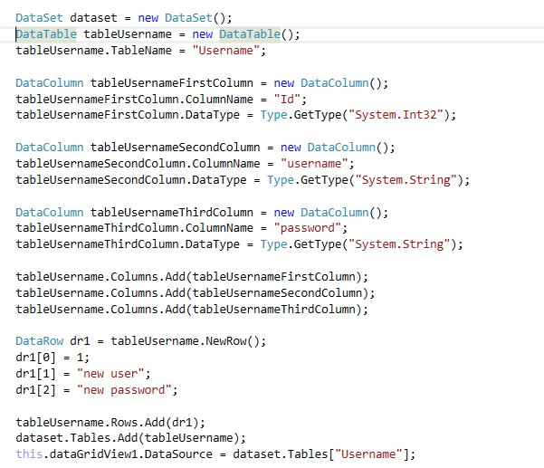

OUTPUT:

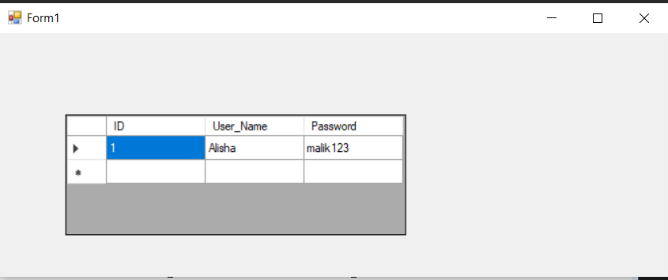

# ACTIVITY 2: STEPS

⇨ Create a windows forms application named ShortCutsApp. ⇨ Create a form in this application named frmShortCut

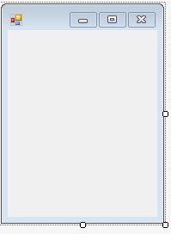

 

⇨ When form loads following interface should be displayed to user.

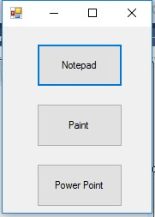

 

⇨ When user clicks button that has text “Notepad”, open a notepad editor for user or simply launch notepad editor.

⇨ When user clicks button with text “Paint”, open MS paint for user. ⇨ When user clicks button with text “Power Point”, open power point for user.

[Note]

⇨ All buttons should be created and displayed at runtime.

⇨ Event handling should also be done at runtime.

⇨ You can use following command for opening relevant application



 

⇨ **System** is namespace

⇨ **Diagnostics** is also namespace

⇨ **Process** is a class: it provides way to start and stop local system processes.

⇨ **Start** is a method that requires name of exe file of application.

Here are names of exe files of applications that are required for example

1. Notepad: notepad.exe
2. Paint: mspaint.exe
3. Power Point: powerpnt.exe

using System;

using System.Collections.Generic;

using System.ComponentModel;

using System.Data;

using System.Drawing;

using System.Linq;

using System.Text;

using System.Threading.Tasks;

using System.Windows.Forms;

namespace Lab08_Task01

{

public partial class Form1 : Form

{

public Form1()

{

InitializeComponent();

}

private void Form1_Load(object sender, EventArgs e)

{

}

private void button1_Click(object sender, EventArgs e)

{

System.Diagnostics.Process.Start("notepad.exe");

}

private void button2_Click(object sender, EventArgs e)

{

System.Diagnostics.Process.Start("mspaint.exe");

}

private void button3_Click(object sender, EventArgs e)

{

System.Diagnostics.Process.Start("POWERPNT.EXE");

}

}

}

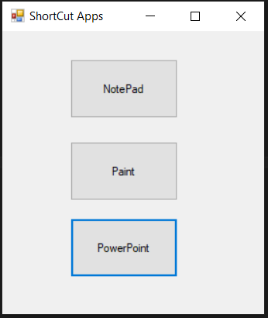

# ACITVITY 3: STEPS

⇨ Create an application named LinqExamples.

⇨ Create a form named frmLinq.

⇨ Create interface of form as given

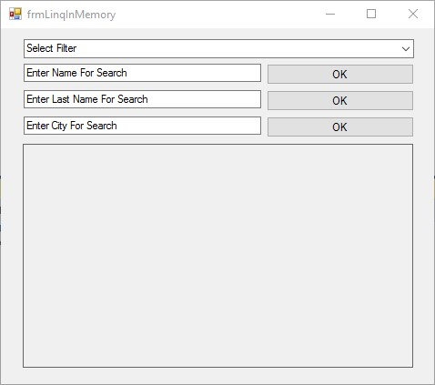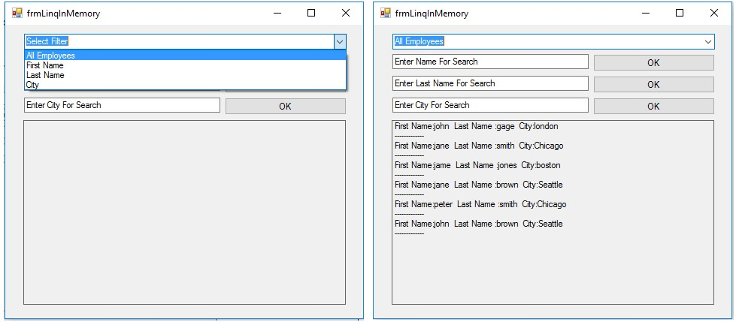

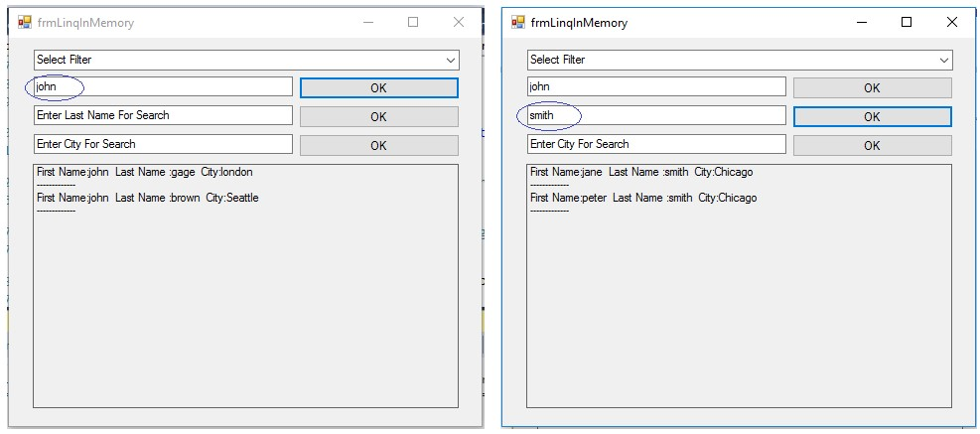

# PROGRAM SETUP

⇨ Create a class named Employee with three fields and three properties.

* **firstName** field and **FirstName** property for it. o **lastName** field and **LastName** property for it.
* **city** field and **City** property for it.

⇨ Create an instance of **List** class named **employees** which should be accessible in all methods of a form, this **employees** will be used as a data holder for different employee objects of **Employee** class.

⇨ Populate the **employees** object of List class using its Add method.

* Note: Here we are adding objects of Employee class in List.

⇨ Before adding employee objects to List setup their values as given here:

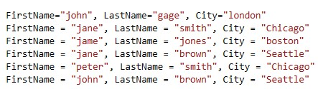

 

# ⇨ Program Requirements

1. Display records from data holder on basis of filter applied using combo box.
2. After that implement following methods for searching records relevant to values of text boxes.

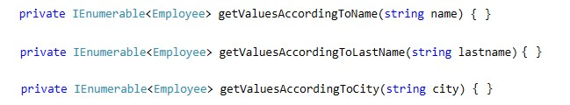

1. Place combo box besides of each text box that shows two values ascending or descending and now display records according to order selected.

[Note]: o You can use orderby clause for this purpose.

o For example: orderby columnName

o After getting filtered records you can write other LINQ query which will sort the records.

Code :

using System;

using System.Collections.Generic;

using System.ComponentModel;

using System.Data;

using System.Drawing;

using System.Linq;

using System.Text;

using System.Threading.Tasks;

using System.Windows.Forms;

namespace Lab08_Task01

{

public partial class Form1 : Form

{

public Form1()

{

InitializeComponent();

}

public class Employee

{

public string name{get; set;}

public string last_name { get; set; }

public string city { get; set; }

}

Employee[] arr = new Employee[6];

string add = "";

private void Form1_Load(object sender, EventArgs e)

{

arr[0] = new Employee { name = "Kulsoom", last_name = "Shaikh", city = "Khairpur" };

arr[1] = new Employee { name = "Koonj", last_name = "Shaikh", city = "Sukkur" };

arr[2] = new Employee { name = "Humera", last_name = "Shaikh", city = "Sukkur" };

arr[3] = new Employee { name = "Kulsoom", last_name = "Alias", city = "Sukkur" };

arr[4] = new Employee { name = "kulsoom", last_name = "koonj", city = "khairpur" };

arr[5] = new Employee { name = "iqra", last_name = "Nadeem", city = "Gilgit" };

}

private void comboBox1_SelectedIndexChanged(object sender, EventArgs e)

{

if (comboBox1.SelectedIndex == 0)

{

var query = from p in arr select p;

foreach (var r in query)

{

add = "First Name : " + r.name + " Last Name : " + r.last_name + " City : " + r.city;

listBox1.Items.Add(add);

}

}

else if (comboBox1.SelectedIndex == 1)

{

var query = from p in arr select p;

listBox1.Items.Clear();

foreach (var r in query)

{

add = "First Name : " + r.name ;

listBox1.Items.Add(add);

}

}

else if (comboBox1.SelectedIndex == 2)

{

var query = from p in arr select p;

listBox1.Items.Clear();

foreach (var r in query)

{

add = "Last Name : " + r.last_name;

listBox1.Items.Add(add);

}

}

else if (comboBox1.SelectedIndex == 3)

{

var query = from p in arr select p;

listBox1.Items.Clear();

foreach (var r in query)

{

add = "City : " + r.city;

listBox1.Items.Add(add);

}

}

}

private void button1_Click(object sender, EventArgs e)

{

var query = from p in arr where p.name == textBox1.Text select p;

listBox1.Items.Clear();

foreach(var r in query)

{

add = "First Name : " + r.name + " Last Name : " + r.last_name + " City : " + r.city;

listBox1.Items.Add(add);

}

}

private void button2_Click(object sender, EventArgs e)

{

var query = from p in arr where p.last_name == textBox2.Text select p;

listBox1.Items.Clear();

foreach (var r in query)

{

add = "First Name : " + r.name + " Last Name : " + r.last_name + " City : " + r.city;

listBox1.Items.Add(add);

}

}

private void button3_Click(object sender, EventArgs e)

{

var query = from p in arr where p.city == textBox3.Text select p;

listBox1.Items.Clear();

foreach (var r in query)

{

add = "First Name : " + r.name + " Last Name : " + r.last_name + " City : " + r.city;

listBox1.Items.Add(add);

}

}

}

}

# Activity 4

⇨ Create an application named MDIApp.

⇨ Create three forms in this application.

⇨ Create interface of form1 as given in image.

⇨ Set **isMdiContainer** property of form1 to **true**.

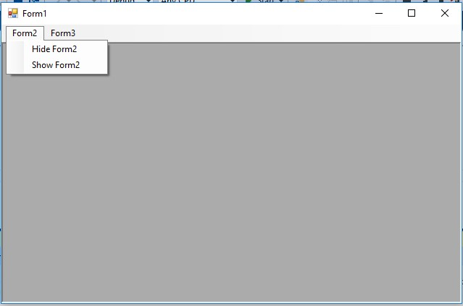

 

⇨ Show form2 using Show() method

⇨ Hide form2 using Hide() method

⇨ Implement FormClosing event of Form2 and Form3 and write following code there.

o Cancel the event by using this line of code: e.Cancel = true; o Now hide the form by using this line of code: this.Hide();

⇨ Do the same with Form3.

⇨ Execute the code and validate the results.

Code:

using System;

using System.Collections.Generic;

using System.ComponentModel;

using System.Data;

using System.Drawing;

using System.Linq;

using System.Text;

using System.Threading.Tasks;

using System.Windows.Forms;

namespace Lab08_Task01

{

public partial class Form1 : Form

{

public Form1()

{

InitializeComponent();

}

Form2 test = new Form2();

Form3 test1 = new Form3();

private void Form1_Load(object sender, EventArgs e)

{

}

private void hideForm2ToolStripMenuItem_Click(object sender, EventArgs e)

{

test.Hide();

}

private void showForm2ToolStripMenuItem_Click(object sender, EventArgs e)

{

test.Show();

}

private void hideForm3ToolStripMenuItem_Click(object sender, EventArgs e)

{

test1.Hide();

}

private void showForm3ToolStripMenuItem_Click(object sender, EventArgs e)

{

test1.Show();

}

}

}

Output:

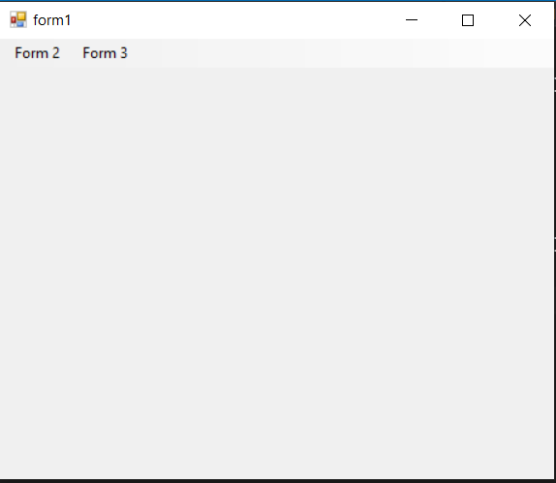

# Activity 5

⇨ Create windows forms application named disconnectedAccess.

⇨ Create a form in it.

⇨ Place DataGridView on form.

⇨ In load event of form place following code.

